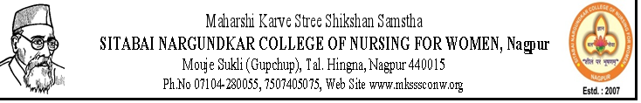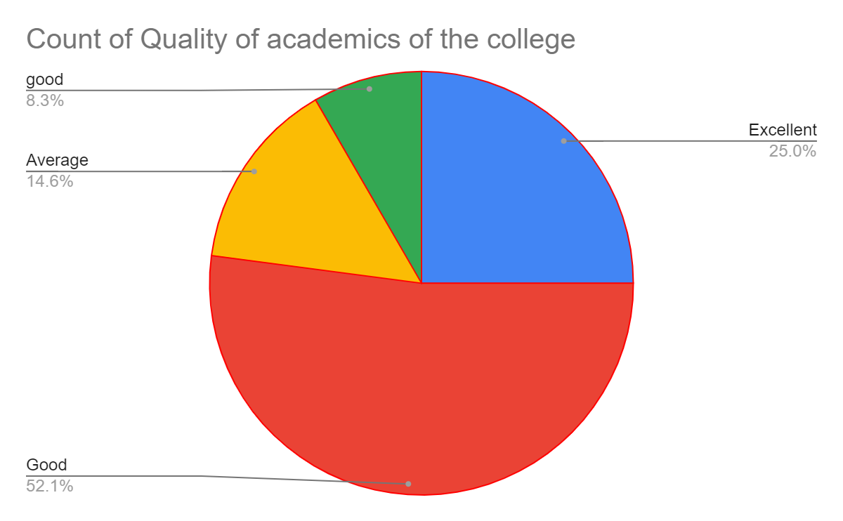
REPORT Professional Feedback Form 2022-23
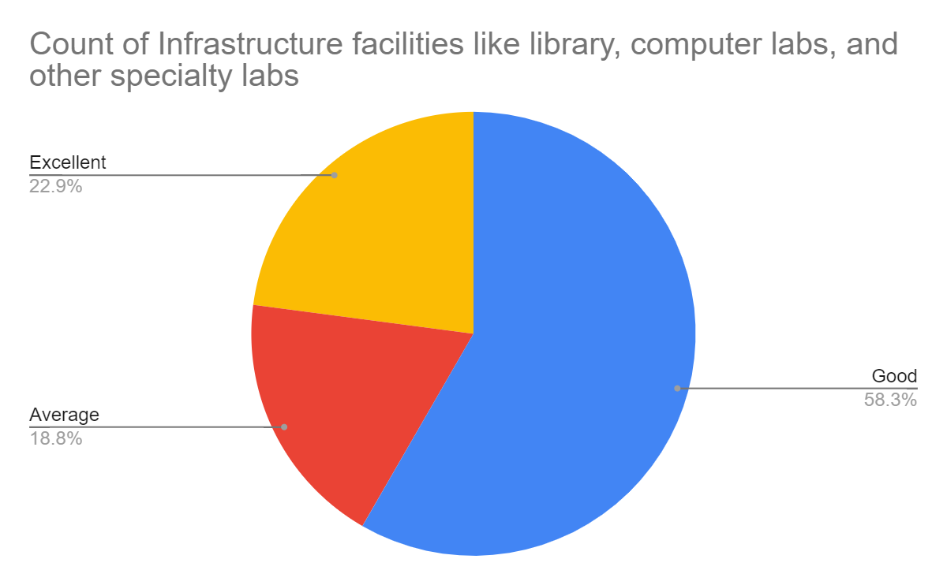
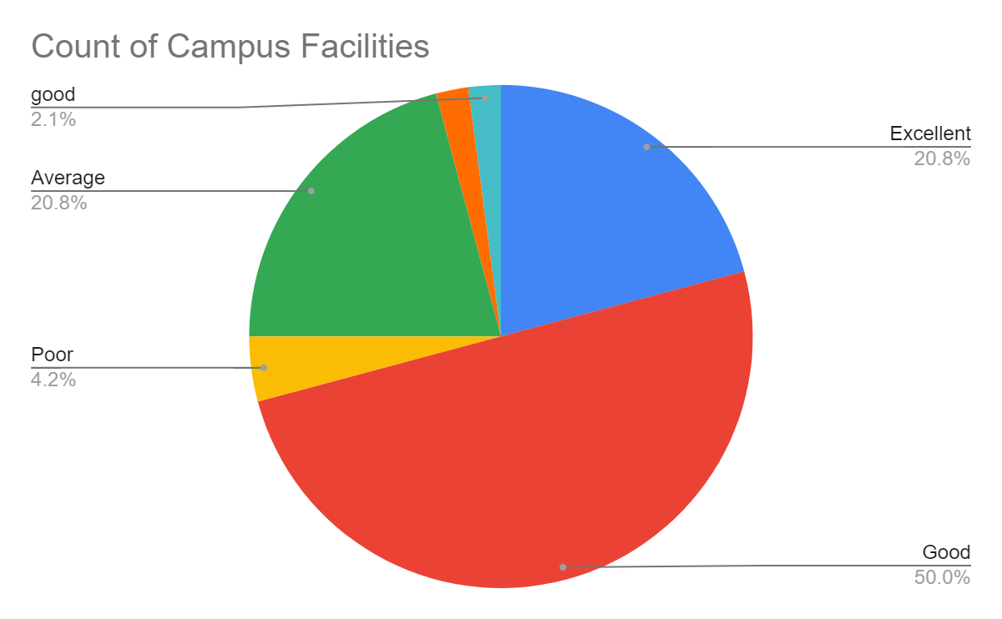
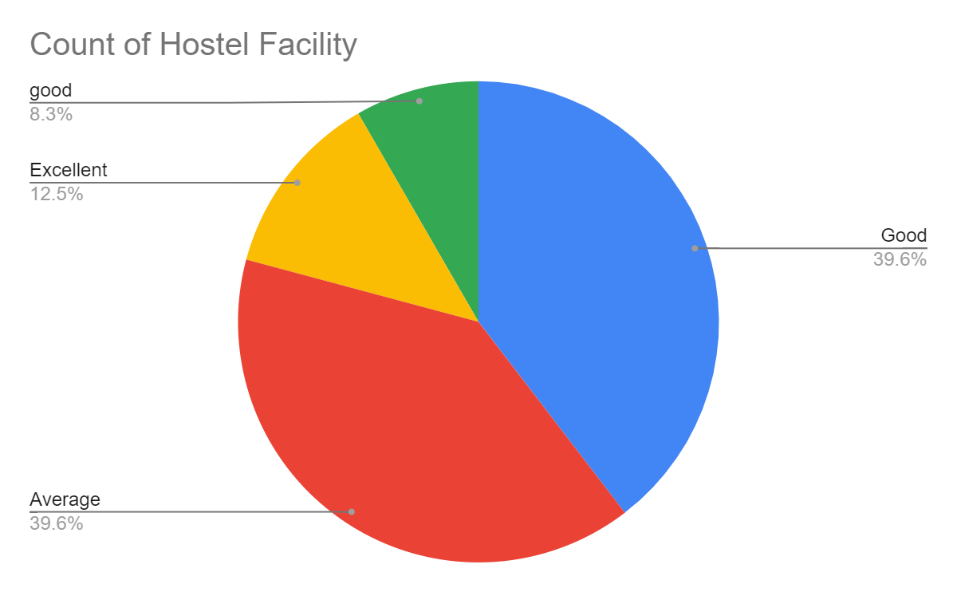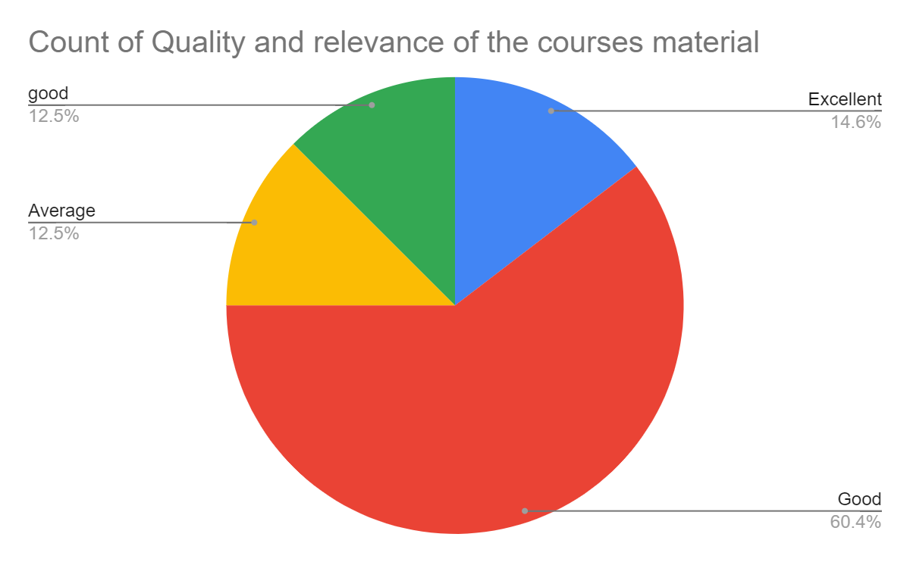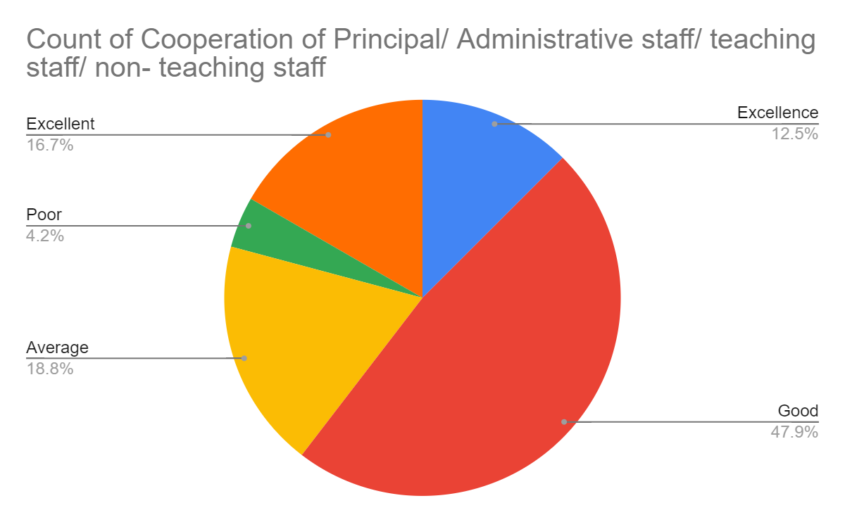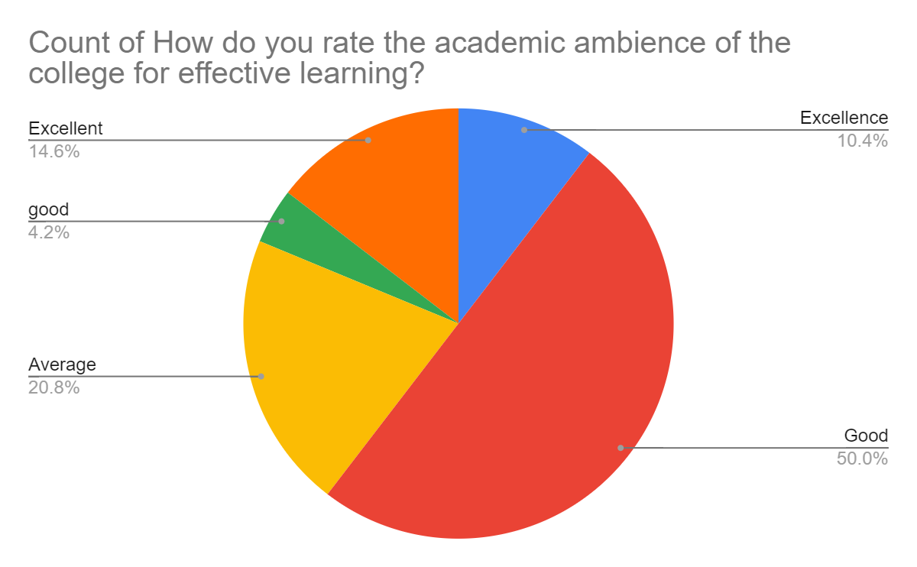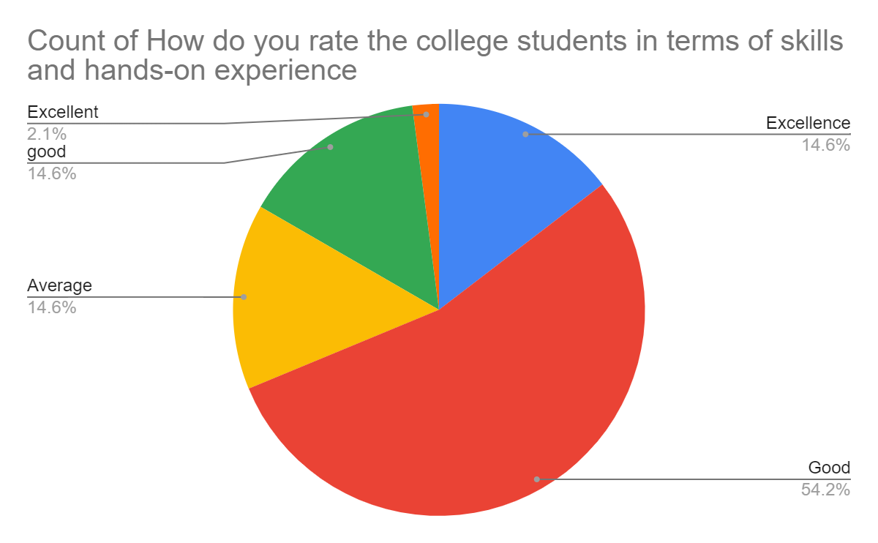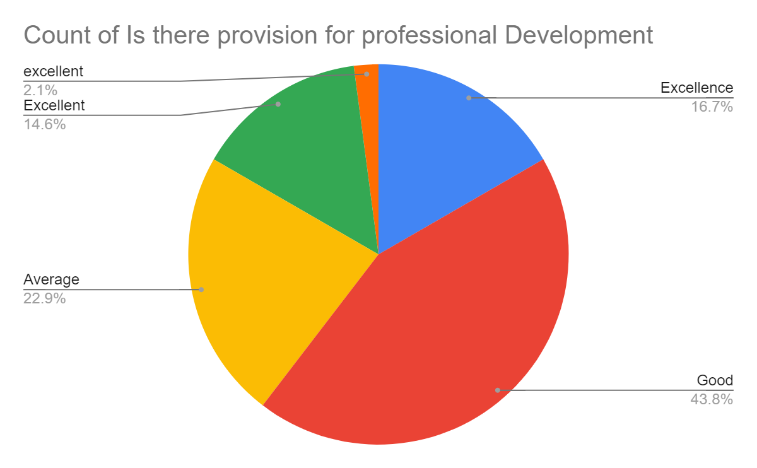

Any Suggestion:
- For Library - I want more books regarding competitive exams.
improve management
- Own hospital
- Transport facility for Safety of hostel students and reduction of programmes
- Improve the quality of food in hostel
- Transport facility for hostel girls need to improved
- FON lab should be improved
- Management can be more productive
- Suggestion for library - I want more books regarding competitive exams related nursing as well as other.
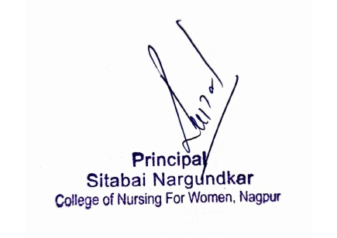
- students and staf are well mannered and disciplined. management of the college is also good.

